Samarth Rural Educational Institute’s
Samarth College of Computer Science, Belhe
Academic Year 2026-2027(SEM-V)
T.Y.B.Sc. (Information Technology)
Practical NO: 7
Title : 7. Development and Testing of GET and POST APIs using Flask and Postman
Roll NO: 70 Batch : C

SET A :
Q1. Student Information API Create a Flask application.
  - Create a GET API /student that returns student details in JSON format.
  - Create a POST API /addstudent that accepts Student Name and Course.
  - Test both APIs using Postman.
Ans:
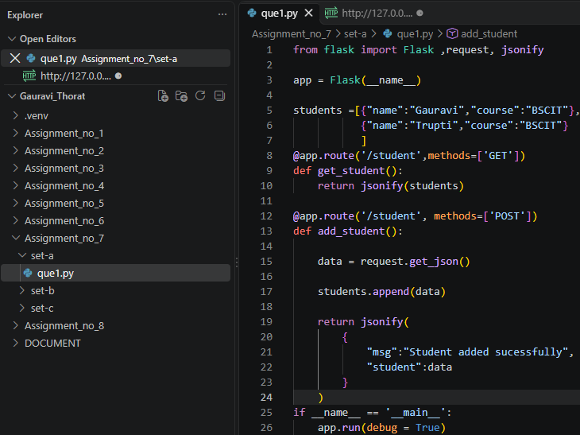
Output:
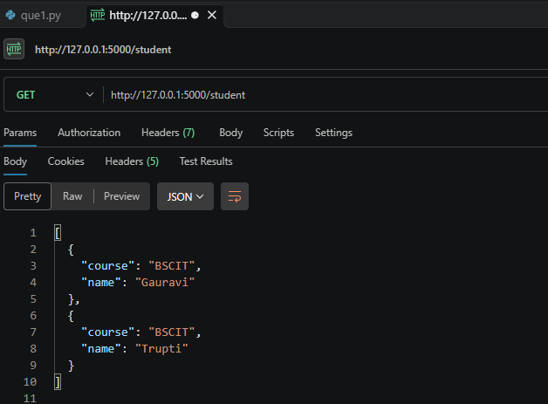
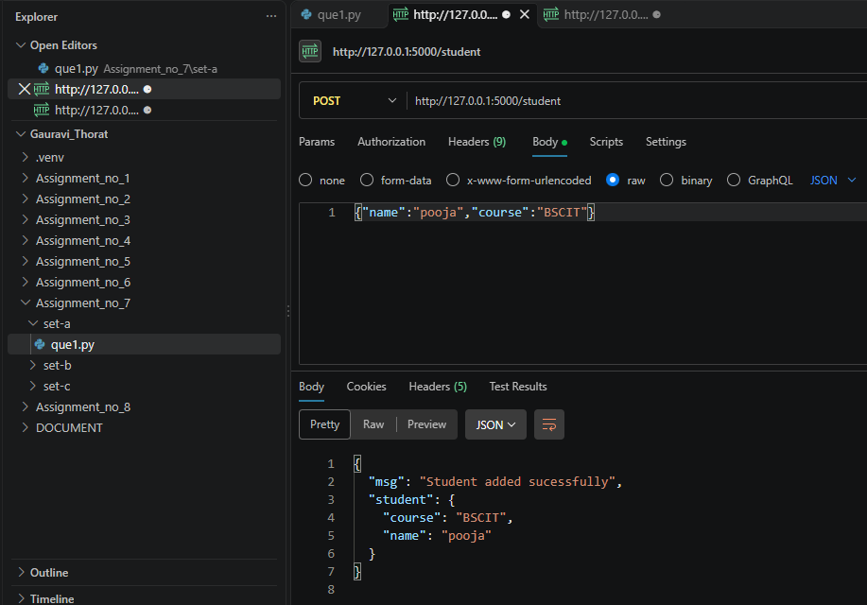
Q2. Employee Information API Create a Flask application.
Requirements:
  - Create a GET API /employee that returns employee details.
  - Create a POST API /addemployee that accepts Employee Name and Department.
  - Test both APIs using Postman.
Ans:
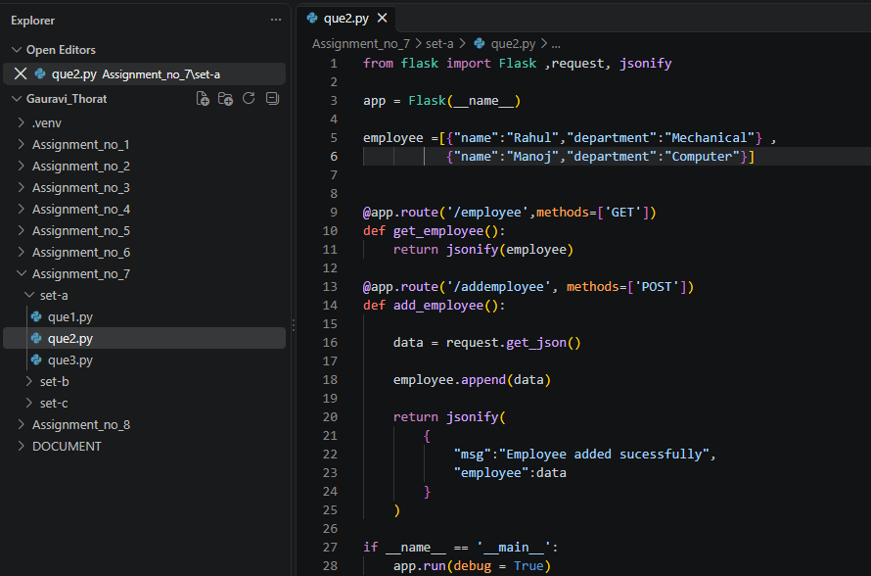
Output:

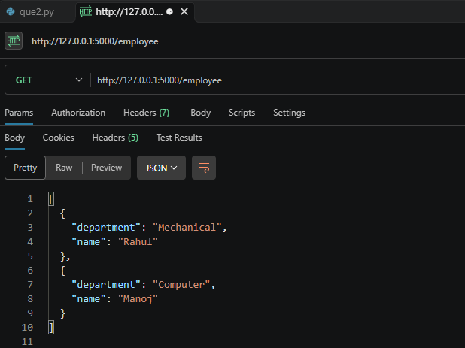
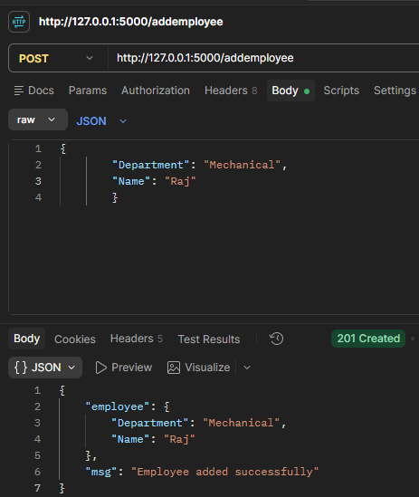

SET B :
Q1. Product Management API Create a Flask application.
Requirements:
  - Create a GET API /products that returns details of at least 3 products.
  - Create a POST API /addproduct that accepts Product Name and Price.
  - Test both APIs using Postman and verify the responses.
Ans:
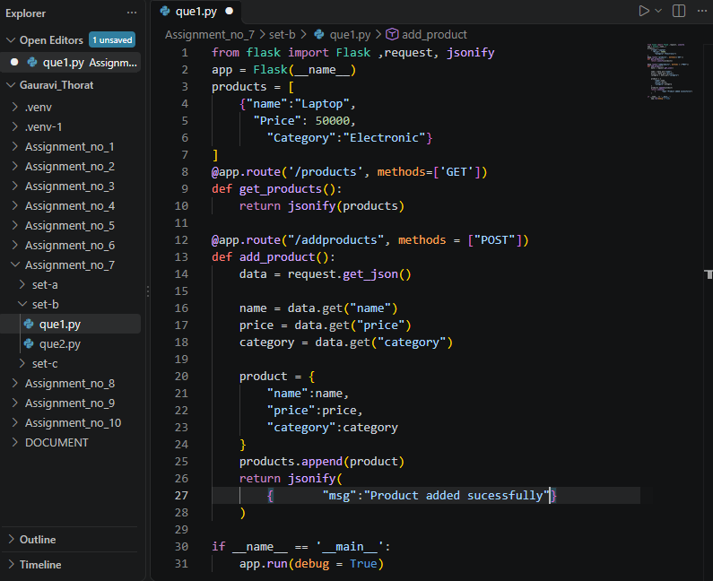

Output:

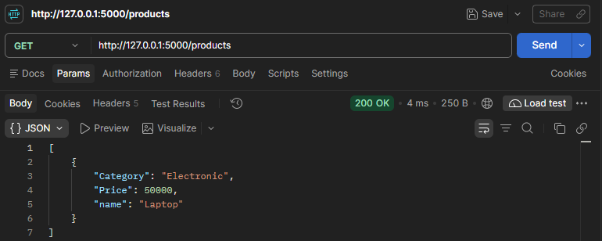
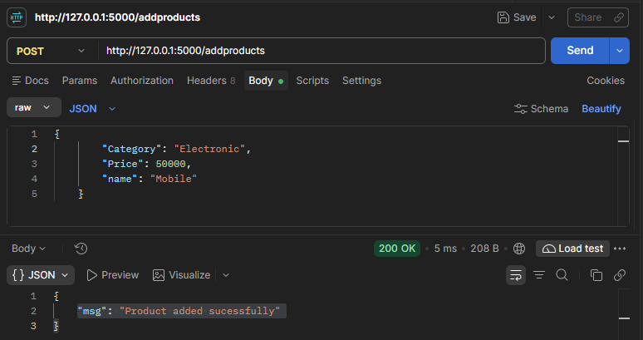

Q2. Create a POST API /order to accept Product Name, Price and Quantity and return the order details with total amount.
Ans:
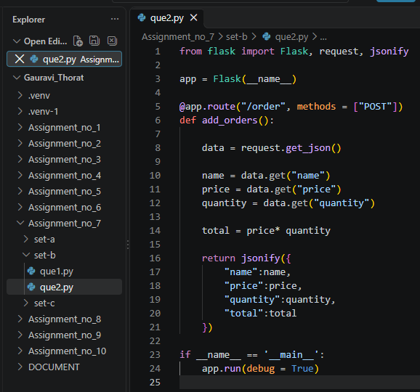
Output:
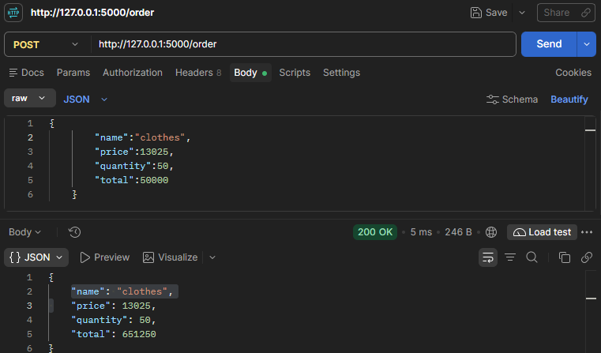

SET C :
Q1. Student Result API
Create a Flask application.
Requirements:
- Create a GET API /result that displays sample student result data.
- Create a POST API /addresult that accepts: Student Name & Marks
- Return: Student , Name ,Marks
- Result (Pass if Marks ≥ 40 else Fail) Test both APIs using Postman.
Ans:
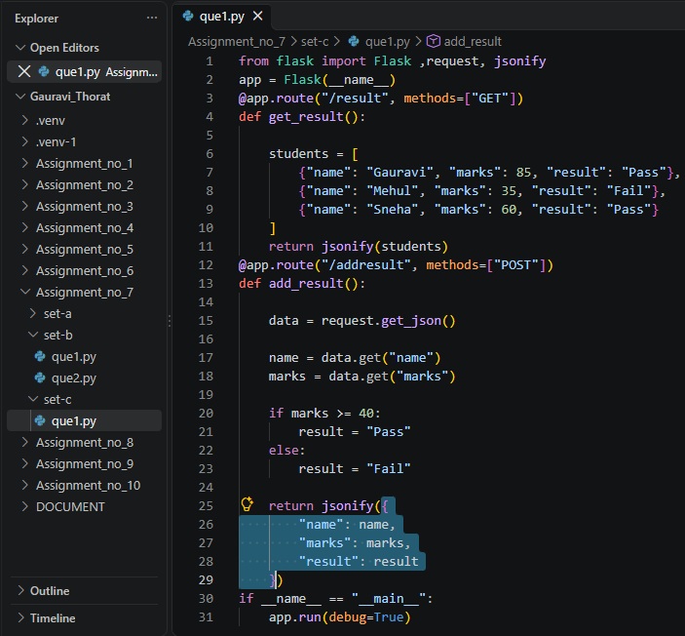

Output:
